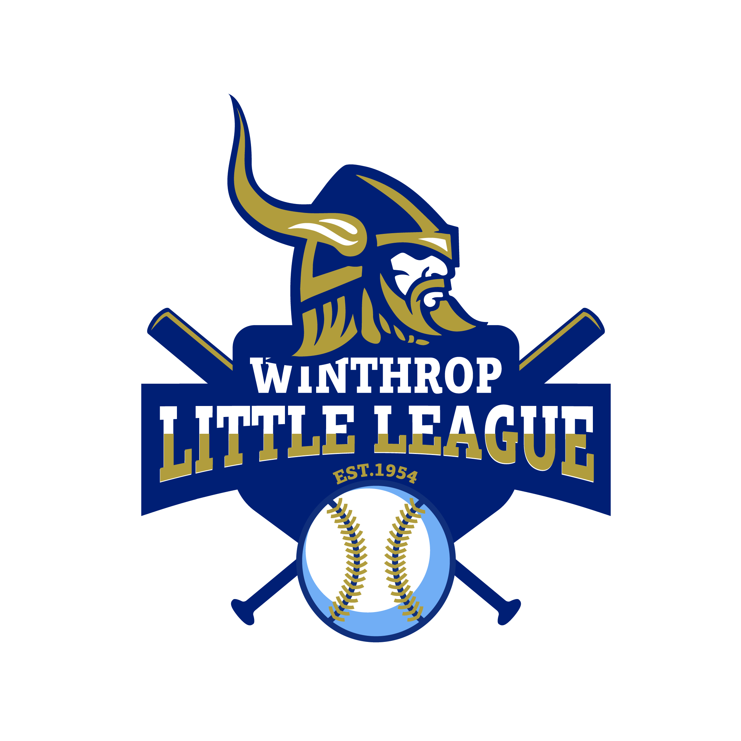

2021 SPONSORSHIP OPPORTUNITIES

GRAND SLAM SPONSOR – $5000 (ONLY 1 Opportunity Available)
• Includes your Company name/logo on the Team Shirt for all A Division Baseball Teams
• Company Name prominently displayed on signage located at the A Field throughout the 2020 season
• Prominent listing on the Winthrop Little League website with direct link to your site
• Company link on our social media site(s) and several acknowledgements throughout the 2020 season
• Recognition during opening ceremonies as THE GRAND SLAM SPONSOR
• Recognition as THE GRAND SLAM SPONSOR during every game announced throughout the 2020 season

PERFECT GAME SPONSOR - $2500 (ONLY 1 Opportunity Available)
• Company Name prominently displayed on signage located at the A Field throughout the 2020 season
• Prominent listing on the Winthrop Little League website with direct link to your site
• Company link on our social media site(s)
• Includes Company name on the Team Shirts for an entire Division (approx. 4-5 teams)

HOMERUN SPONSOR – $750
• Includes your Company name on the Team Shirt for one B, C or T-ball Division team
• Company Name prominently displayed on signage located at the A Field throughout the 2020 season
• Company link on our social media site(s)
• Prominent listing on the Winthrop Little League website with direct link to your site

TRIPLE SPONSOR – $300
• Company Name prominently displayed on signage located at the A Field throughout the 2020 season
• Company link on our social media site(s)
• Prominent listing on the Winthrop Little League website with direct link to your site

DOUBLE SPONSOR – $100
• Company Name prominently displayed on signage located at the A Field throughout the 2020 season
• Company link on our social media site(s)

SINGLE SPONSOR – $50
• Company link on our social media site(s)
• Prominent listing on the Winthrop Little League website with direct link to your site

